Model Selection: A Comparative Study of Supervised Learning Models
Yomna Othman
Department of Computer Science and Engineering
The American University in Cairo
Cairo, Egypt
yomnaothman@aucegypt.edu

Jacques Elia
Department of Computer Science and Engineering
The American University in Cairo
Cairo, Egypt
jacquesjeanelia@aucegypt.edu

ABSTRACT
In this phase we compare every supervised learning model covered in the course on the cleaned dataset from Phase II: predicting whether a cryptocurrency's price rises or falls by more than 0.2% over the next hour. We tune eleven models (logistic and linear regression, k-nearest neighbors, a decision tree, a random forest, Gaussian Naive Bayes, a Bayesian network, AdaBoost, linear and kernel support vector machines, and a neural network) with a grid search on a time-based validation set, select them by log loss, and analyze the variability of the three best models with a bootstrap, repeated random seeds, and a breakdown by coin and by month. All models beat the baseline, but by small margins: the best single run reaches 53.0% validation accuracy and an AUC of 0.544, against 50.6% for always predicting the majority class. The neural network has the lowest validation loss, but retraining it with other random seeds shows that this lead comes from a fortunate early stop rather than a better model, and the clearest source of variability is the market itself, with AUC changing more between months than between models. We therefore select the random forest, the most reliable of the top models, which reaches 52.4% accuracy and an AUC of 0.532 on the test period.
KEYWORDS
Model selection, Supervised learning, Cryptocurrency, Bootstrap, Random forest
1. Experimental Setup
Task and Data We use the dataset built in Phase II: 15-minute bars for 10 large-cap pairs, 36 features (26 standardized numeric features and 10 one-hot pair indicators), and a binary label that is 1 if the price rises by more than 0.2% over the next hour and 0 if it falls by more than 0.2%. Following the feedback on Phase II, the trading pair is now one-hot encoded and used as an input by every model, so that a single model can still learn patterns that differ between coins; at prediction time, the pair chosen by the user is encoded in the same way. The problem is a classification problem from the start, so no discretization of the label is needed; we still include linear regression, which predicts the 0/1 label as a number that we threshold at 0.5, as the regression counterpart.
Splits We keep the chronological split from Phase II (Table 1). Hyperparameters and models are chosen on the validation set only; the test set is used only to evaluate a selected model, and Section 5 lists every test evaluation that was made.
Table 1: Data splits used in this phase.
Split | Period | Instances | Up
Train | Jan 2020 - Sep 2024 | 1,127,670 | 50.7%
Validation | Oct 2024 - Jun 2025 | 188,886 | 50.6%
Test | Jul 2025 - Aug 2026 | 281,294 | 49.8%
Metrics Our main metric is the log loss on the validation set, which scores the predicted probability of an upward move rather than only the predicted class. With two balanced classes and a weak signal, accuracy changes by only a fraction of a percent between models, while log loss rewards models that are confident when they are right and penalizes confident mistakes, which matters for a trading application where the probability would be used to size a position. A model that always predicts the training share of upward moves scores 0.6931, so every model must stay below this value to show any predictive power. We also report the AUC, which measures how well the predicted probabilities rank upward moves above downward ones, together with accuracy, precision, recall and F1 at a 0.5 threshold.
Protocol For each model we run a grid search: every combination of hyperparameters is trained on the training set and scored on the validation set, and the best combination by validation log loss is retrained and evaluated in full. When the best value of a hyperparameter was at the edge of its grid, we extended the grid in that direction and searched again. Models whose cost grows quickly with the number of rows were trained on a random sample of the training set: 200,000 rows for k-nearest neighbors and the first rounds of the Bayesian network and the neural network, and 20,000 for the kernel SVM. All models are scored on the full validation set. The experiments use scikit-learn [2] and pyAgrum [3] on a 14-core laptop; the full search takes about 6.5 hours.
2. Models
For every model we give the hyperparameters searched (the full results of every search are saved in out/results), the validation results of the best setting, and a comment on its strengths, weaknesses and fit for the problem. Table 14 in Section 3 compares all models side by side.
2.1 Baselines The majority classifier predicts the share of upward moves in the training set (50.7%) for every instance. It always predicts an upward move, so its accuracy equals the share of upward moves (50.6% on validation), and its log loss of 0.6931 is the reference every model must beat. Linear regression fits the 0/1 label directly by least squares and is thresholded at 0.5; its outputs are clipped to [0, 1] to compute the log loss. It reaches a log loss of 0.6908 and an AUC of 0.538, almost identical to logistic regression, because the predicted probabilities all stay close to 0.5, where a straight line and the logistic curve are nearly the same. It is fast and transparent, but it is not designed to produce probabilities and can output values outside [0, 1].
2.2 Logistic Regression We searched five solvers with L1, L2, elastic-net and no regularization, and inverse regularization strengths C from 10^-5 to 10^-2 (Table 2). The best setting reaches a validation log loss of 0.6908, an AUC of 0.538 and an accuracy of 52.7%, with a training log loss of 0.6896; it trains in 0.3 s. The best C of 10^-4 is a strong penalty: the model keeps only a small, stable signal, mostly the short-term mean reversion found in Phase II, and all solvers converge to nearly the same model. Logistic regression is fast, deterministic, gives well-calibrated probabilities and interpretable coefficients, and has the smallest gap between training and validation loss of the strong models. Its weakness is that it can only combine the features linearly, so it cannot use interactions such as a reversion effect that depends on volatility.
Table 2: Logistic regression search.
Parameter | Values tried | Best
solver | lbfgs, liblinear, newton-cg, sag, saga | lbfgs
penalty | elasticnet, l1, l2, none | l2
C | 1e-05, 0.0001, 0.001, 0.01 | 0.0001
2.3 k-Nearest Neighbors Predicting with k-nearest neighbors requires comparing each instance with the whole training set, so we used the 200,000-row sample. We first swept k from 100 to 5,000 with a single neighbor search, then compared uniform and distance weights and the Euclidean and Manhattan metrics at the best k (Table 3). The best setting reaches a validation log loss of 0.6907, an AUC of 0.538 and an accuracy of 52.6%, with a training log loss of 0.0000; it trains in under 0.1 s. The best k of 3,500 is very large: with a signal this weak, a neighborhood only becomes informative when it averages thousands of past situations, which turns the model into a smooth local average. Its training log loss is zero only because with distance weights each training point is its own nearest neighbor at distance zero, so it is not a sign of overfitting. The model needs no training, but it stores the whole sample and is by far the slowest to predict (55.8 s for the validation set), which makes it a poor fit for real-time predictions.
Table 3: k-nearest neighbors search (k first, then weights and metric at the best k).
Parameter | Values tried | Best
k | 100, 250, 500, 1000, 1500, 2000, 2500, 3000, 3500, 4000, 5000 | 3500
weights | distance, uniform | distance
metric | euclidean, manhattan | euclidean

2.4 Decision Tree We searched the split criterion, the splitter, the maximum depth and the minimum number of instances per leaf (Table 4); an earlier search showed that the entropy and log-loss criteria are identical and that a minimum impurity decrease of 0.1 blocks every split, so those values were dropped. The best setting reaches a validation log loss of 0.6919, an AUC of 0.532 and an accuracy of 52.3%, with a training log loss of 0.6890; it trains in 8.7 s. The best tree is shallow (depth 4) with large leaves, because deeper trees start fitting noise. A single tree is easy to read and explain, but its probabilities are coarse, since every instance in a leaf receives the same value, and it is unstable: small changes in the data can change the splits. This makes it one of the weakest models by log loss.
Table 4: Decision tree search.
Parameter | Values tried | Best
criterion | entropy, gini | entropy
splitter | best, random | best
max_depth | 2, 3, 4, 5, 6 | 4
min_samples_leaf | 500, 1000, 2000, 3000 | 2000
min_samples_split | 2 | 2
max_leaf_nodes | none | none
min_impurity_decrease | 0.0 | 0.0
2.5 Random Forest A first search with depths 6 to 8 peaked at the deepest value, so we extended it to depths 10, 12 and 16 (Table 5). The best setting reaches a validation log loss of 0.6907, an AUC of 0.539 and an accuracy of 52.8%, with a training log loss of 0.6849; it trains in 19.3 s. Depth 8 remains the best: deeper forests keep lowering the training loss but not the validation loss, the classic sign of overfitting. Forests of 400 trees never beat 100 to 200 trees. The random forest averages many decorrelated trees, which fixes the instability of a single tree, captures interactions between features, and gives feature importances. Its drawbacks are a larger gap between training and validation loss than the linear models and a much larger model to store.
Table 5: Random forest search (second round).
Parameter | Values tried | Best
n_estimators | 100, 200 | 100
max_features | 0.2, sqrt | sqrt
max_depth | 8, 10, 12, 16 | 8

2.6 Gaussian Naive Bayes The only hyperparameter is the variance smoothing, which adds a fraction of the largest feature variance to every variance (Table 6). The best setting reaches a validation log loss of 0.6921, an AUC of 0.535 and an accuracy of 51.6%, with a training log loss of 0.6916; it trains in 0.2 s. The best smoothing is very large (10.0), which flattens the class-conditional densities and pulls the probabilities toward 0.5: without it the model is overconfident, because it assumes the features are independent while many of them are strongly correlated (0.93 between returns and body ratio, Phase II). The model is extremely fast and simple, but its predictions are lopsided, with a recall of only 27% for upward moves, and its independence assumption is clearly violated by our features.
Table 6: Gaussian Naive Bayes search.
Parameter | Values tried | Best
var_smoothing | 1e-09, 1e-08, 1e-07, 1e-06, 1e-05, 0.0001, 0.001, 0.01, 0.1, 1, 10, 20, 50, 100, 200 | 10
2.7 Bayesian Network We used the scikit-learn interface of pyAgrum [3], which discretizes each feature and learns a network structure. The inputs are rounded to six decimals first, because the day-of-week encoding stores equal values as slightly different floats, which makes pyAgrum fail. A fit on the full training set needs about 9 GB of memory, so we searched in two rounds, like the neural network. The first round compared five structure-learning methods (Naive Bayes, tree-augmented Naive Bayes (TAN), Chow-Liu, MIIC and greedy hill climbing (GHC)), two discretizations (equal-width and equal-frequency bins) and the number of bins on the 200,000-row sample, five fits at a time (Table 7). TAN and GHC with equal-width bins were the best, with the best number of bins at the smallest value tried, so the second round refitted these on the full training set, one at a time, with 2 bins added (Table 8). The best setting reaches a validation log loss of 0.6915, an AUC of 0.532 and an accuracy of 52.3%, with a training log loss of 0.6906; it trains in 56.5 s. Training on the full data improved the validation log loss from 0.6924 to 0.6915. On the full data, greedy hill climbing overtook TAN: with more rows, the more flexible structure search can find more dependencies. Unlike Gaussian Naive Bayes, both structures let features depend on each other, which handles the correlated features better, and the learned graph can be inspected. However, discretizing continuous features into a few bins discards much of the small signal available, which keeps the model behind the continuous models.
Table 7: Bayesian network search, round 1 (200k sample).
Parameter | Values tried | Best
structure | Chow-Liu, GHC, MIIC, NaiveBayes, TAN | TAN
discretization | quantile, uniform | uniform
n_bins | 3, 5, 10 | 3
Table 8: Bayesian network search, round 2 (full data).
Parameter | Values tried | Best
structure | GHC, TAN | GHC
discretization | uniform | uniform
n_bins | 2, 3, 5 | 5
2.8 AdaBoost We boosted decision stumps (depth 1) and depth-2 trees with 400 to 1,500 rounds and learning rates from 0.1 to 1.0 (Table 9). The best setting reaches a validation log loss of 0.6910, an AUC of 0.536 and an accuracy of 52.5%, with a training log loss of 0.6883; it trains in 53 min. Stumps beat deeper base trees, which again shows that extra flexibility mostly fits noise. The best setting uses the largest number of rounds and the largest learning rate in the grid, so more rounds might help slightly, but the search already took over four hours because boosting is sequential and cannot be parallelized within one model. AdaBoost focuses on the instances it misclassifies, which in a noisy problem means it spends its effort on moves that are essentially random.
Table 9: AdaBoost search.
Parameter | Values tried | Best
base tree depth | 1, 2 | 1
n_estimators | 400, 800, 1000, 1500 | 1500
learning_rate | 0.1, 0.3, 0.5, 1 | 1
2.9 Linear SVM A linear SVM outputs a distance from the separating hyperplane rather than a probability, so we wrapped it in sigmoid (Platt) calibration with 3-fold cross-validation. We searched the regularization C and the stopping tolerance (Table 10). The best setting reaches a validation log loss of 0.6909, an AUC of 0.538 and an accuracy of 52.8%, with a training log loss of 0.6899; it trains in 7 min. The tolerance had no effect on the result. The model is essentially a differently-trained linear classifier, and it ends up very close to logistic regression, but it needs an extra calibration step to give probabilities and is slower to train.
Table 10: Linear SVM search.
Parameter | Values tried | Best
C | 0.01, 0.1, 1, 10, 100 | 1
penalty | l2 | l2
loss | squared_hinge | squared_hinge
dual | True | True
tol | 0.0001, 0.001, 0.01, 0.1 | 0.1
class_weight | none | none
2.10 Kernel SVM An RBF-kernel SVM can learn non-linear boundaries, but its training cost grows roughly with the square of the number of rows, so we trained it on 20,000 rows. A first search peaked at the smallest C and gamma, so we extended both downward (Table 11). The best setting reaches a validation log loss of 0.6912, an AUC of 0.535 and an accuracy of 52.6%, with a training log loss of 0.6890; it trains in 29.9 s. Almost every training instance becomes a support vector (19,389 of 20,000), which shows that the classes overlap almost completely. The model is limited by the small sample, and predicting the validation set takes 104.5 s because every prediction is compared with every support vector, so it does not scale to our data.
Table 11: Kernel SVM search.
Parameter | Values tried | Best
C | 0.01, 0.03, 0.1, 1 | 0.1
gamma | 0.001, 0.003, 0.01, scale | 0.01
2.11 Neural Network (MLP) In the first round we searched 48 multilayer perceptrons on the 200,000-row sample (Table 12), with early stopping on 10% of the training data. The best was the smallest network, a single layer of 64 neurons trained with stochastic gradient descent, while larger networks and the Adam and L-BFGS solvers overfitted. Since the best values were at the edge of the grid, the second round searched smaller networks and stronger L2 regularization (alpha) on the full training set (Table 13). With the seed used in the search, the second round improved the validation log loss from 0.6908 to 0.6902, and the largest network with the weakest regularization was again the worst. The best setting reaches a validation log loss of 0.6902, an AUC of 0.544 and an accuracy of 53.0%, with a training log loss of 0.6870; it trains in 30.8 s. However, this result does not hold up with other random seeds (Section 4): the seed controls which 10% of the training rows are used for early stopping, and with the seed used in the search, training happened to stop after 33 epochs, while five other seeds trained for 93 to 140 epochs and reached a worse validation loss (0.6920 on average). The MLP can model non-linear interactions between features, but it is the least interpretable model, it depends on many hyperparameters, and on this problem its result depends strongly on when training stops.
Table 12: Neural network search, round 1 (200k sample).
Parameter | Values tried | Best
hidden layers | (64,), (64, 32), (128, 64) | (64,)
activation | relu | relu
solver | adam, lbfgs, sgd | sgd
alpha | 0.0001, 0.01 | 0.0001
initial learning rate | 0.001, 0.01 | 0.001
learning_rate | adaptive, constant, invscaling | constant
Table 13: Neural network search, round 2 (full data).
Parameter | Values tried | Best
hidden layers | (8,), (16,), (32,), (64,) | (64,)
alpha | 0.01, 0.03, 0.1, 0.3, 1 | 0.03
3. Comparison of All Models
Table 14: Validation results of every model at its best setting, sorted by log loss.
Model | Acc. | F1 | AUC | Log loss | Train log loss | Fit time
MLP (full data) | 53.0 | 0.534 | 0.544 | 0.6902 | 0.6870 | 30.8 s
Random Forest | 52.8 | 0.541 | 0.539 | 0.6907 | 0.6849 | 19.3 s
KNN | 52.6 | 0.548 | 0.538 | 0.6907 | 0.0000 | under 0.1 s
Logistic Regression | 52.7 | 0.558 | 0.538 | 0.6908 | 0.6896 | 0.3 s
Linear Regression | 52.7 | 0.556 | 0.538 | 0.6908 | 0.6896 | 0.3 s
MLP (200k sample) | 52.8 | 0.540 | 0.541 | 0.6908 | 0.6875 | 8.1 s
Linear SVM | 52.8 | 0.559 | 0.538 | 0.6909 | 0.6899 | 7 min
AdaBoost | 52.5 | 0.533 | 0.536 | 0.6910 | 0.6883 | 53 min
Kernel SVM | 52.6 | 0.583 | 0.535 | 0.6912 | 0.6890 | 29.9 s
Bayesian Network (full data) | 52.3 | 0.540 | 0.532 | 0.6915 | 0.6906 | 56.5 s
Decision Tree | 52.3 | 0.514 | 0.532 | 0.6919 | 0.6890 | 8.7 s
Naive Bayes | 51.6 | 0.358 | 0.535 | 0.6921 | 0.6916 | 0.2 s
Bayesian Network (200k sample) | 52.1 | 0.517 | 0.530 | 0.6924 | 0.6906 | 40.0 s
Majority | 50.6 | 0.672 | 0.500 | 0.6931 | 0.6931 | under 0.1 s

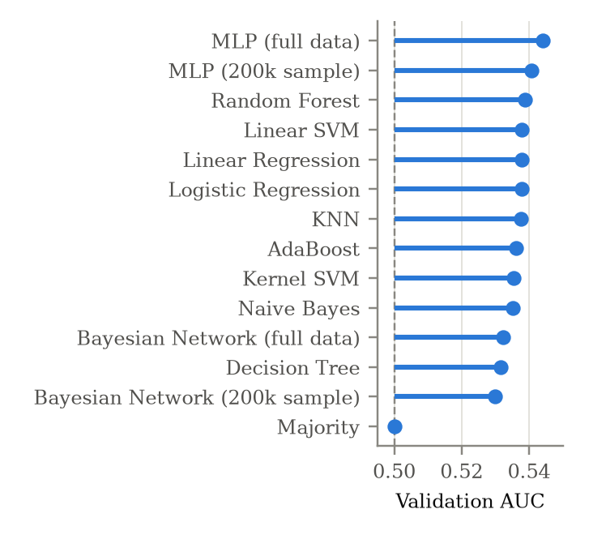
Figure 1: Validation AUC of every model (dashed line: no predictive power).
Table 14 and Figure 1 show that every model beats the majority baseline, but the margins are small: the best accuracy is 53.0%, against 50.6% for the baseline, and the AUCs range from 0.530 to 0.544. This is expected for liquid markets, where any strong and simple signal is quickly traded away, and it matches the small correlations found in Phase II. The ranking follows a clear pattern. Models that produce smooth probabilities from all features (the neural network, random forest, k-nearest neighbors and the linear models) form a tight group at the top, while models with coarse probabilities or strong simplifying assumptions are at the bottom: the Bayesian network discretizes the inputs, Naive Bayes assumes the features are independent, and the single decision tree gives the same probability to every instance in a leaf. Within the top group the differences are in the fourth decimal of the log loss, so a ranking based on a single number is not reliable; Section 4 examines whether these differences are real. The costs, on the other hand, differ by orders of magnitude: logistic regression trains in under a second, while AdaBoost needs about an hour for a worse result.
4. Variability of the Top Three Models
The three models with the lowest validation log loss are MLP (full data), Random Forest and KNN. We study four sources of variability: the finite validation set, the randomness of training, the coin, and the time period. Unless stated otherwise, the neural network results use the seed of the search.
Validation Sample We resampled the validation set with replacement 200 times (a bootstrap [4]) and recomputed the log loss of each model on the same resamples. Table 15 gives the 95% interval of each model and how often each model had the lowest loss. The gap between the first two models (0.00049) is large compared with the width of the intervals (about 0.0007), and the neural network is best in 100% of the resamples, so on the validation set alone its lead looks real. The next paragraph shows why it is not.
Table 15: Bootstrap of the validation log loss (200 resamples).
Model | Log loss | 95% interval | Best in
MLP (full data) | 0.6902 | 0.6897 - 0.6906 | 100%
Random Forest | 0.6907 | 0.6903 - 0.6910 | 0%
KNN | 0.6907 | 0.6904 - 0.6910 | 0%
Training Randomness We retrained each model with five new random seeds (Table 16). k-nearest neighbors is deterministic, so its result does not change, and the random forest changes by only 0.00001. The neural network behaves very differently: with the five new seeds its log loss averages 0.6920, against 0.6902 with the seed used in the search, which places it behind the random forest and k-nearest neighbors. The seed decides which 10% of the training rows are held out for early stopping. These rows come from the same period as the rest of the training data, so the held-out score keeps improving as the network trains longer (93 to 140 epochs), while the validation loss on the later period gets worse. The seed used in the search stopped training after only 33 epochs, which is why it looked best. Because the search compared 20 settings with a single seed each, it favored the setting whose seed happened to stop early, a form of the winner's curse. The bootstrap of the previous paragraph does not capture this, since it only resamples the validation set.
Table 16: Results over five random seeds (mean and standard deviation).
Model | Log loss | Std | AUC | Std
MLP (full data) | 0.69198 | 0.000306 | 0.5404 | 0.00060
Random Forest | 0.69069 | 0.000012 | 0.5387 | 0.00013
KNN | 0.69074 | 0.000000 | 0.5377 | 0.00000

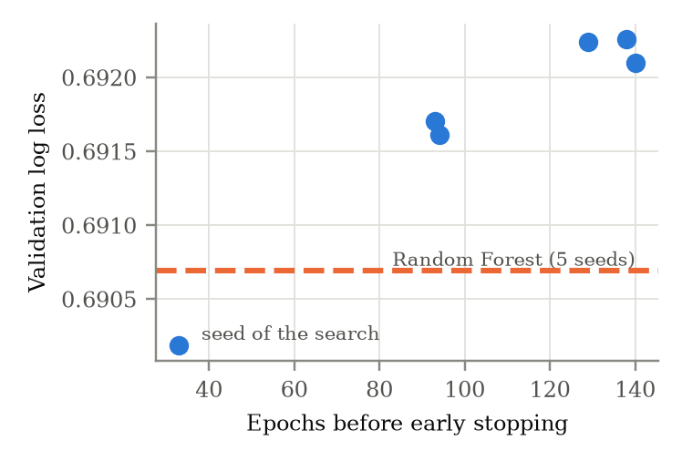
Figure 3: Validation log loss of the final neural network setting retrained with six seeds, against the number of epochs before early stopping.
Coins Table 17 gives the AUC of each model on each pair. The differences between coins are larger than the differences between models: for MLP (full data), the AUC ranges from 0.537 on LINK to 0.557 on ETH. The three models agree on which coins are easier to predict, which suggests that the difference comes from the coins, for example their liquidity and volatility, rather than from the models. MLP (full data) has the highest AUC on 10 of the 10 coins.
Table 17: Validation AUC by trading pair.
Pair | Up | MLP (full data) | Random Forest | KNN
ADA | 49.8% | 0.545 | 0.540 | 0.538
AVAX | 49.8% | 0.538 | 0.532 | 0.530
BNB | 51.7% | 0.539 | 0.536 | 0.532
BTC | 51.8% | 0.545 | 0.541 | 0.540
DOGE | 50.7% | 0.542 | 0.540 | 0.539
ETH | 51.7% | 0.557 | 0.548 | 0.548
LINK | 49.6% | 0.537 | 0.535 | 0.534
LTC | 50.5% | 0.548 | 0.545 | 0.546
SOL | 50.7% | 0.540 | 0.532 | 0.533
XRP | 50.6% | 0.546 | 0.540 | 0.537

Time Period Figure 2 shows the AUC of the three models in each month of the validation period. This is the largest source of variability: the AUC moves between 0.520 and 0.569 from month to month, and the three models move together. The share of upward moves also changes, from 48.7% to 53.8%. Cryptocurrency markets are non-stationary: the strength of the mean-reversion effect depends on the market regime, so a model trained on 2020 to 2024 works better in some months than in others, regardless of the model.
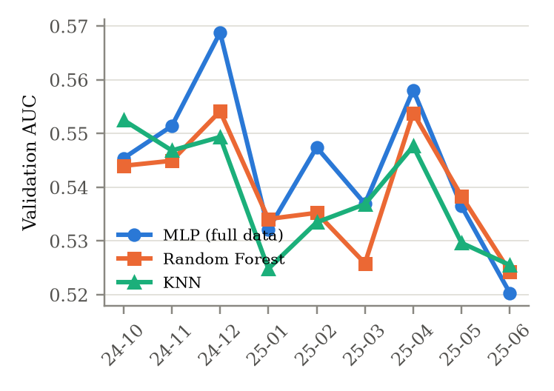
Figure 2: Validation AUC of the three best models by month.
Overfitting The gap between training and validation log loss (Table 14) measures how much of the training fit does not carry over to new data. It is smallest for the linear models and larger for the random forest and the neural network, which have more capacity; for these models we kept the capacity small (depth 8, one hidden layer) because larger settings increased the gap without improving validation results.
Reasons for the Variability Overall, the differences between the top models are small compared with the uncertainty of the validation set, the randomness of training the neural network, and the differences between months and coins. All models learn the same weak signal identified in Phase II, mainly short-term mean reversion, so they converge to similar results; the remaining differences come from how smoothly each model turns this signal into probabilities, from the amount of training data each model could use, from how much the training procedure depends on chance, and from the market regime of each period.
5. Model Choice
Performance With a single seed, the neural network has the lowest validation log loss (0.6902) and comes out best in 100% of the bootstrap resamples, but Section 4 shows that this lead does not survive a change of seed. Averaged over seeds, the random forest has the best validation log loss of the top models (0.69069, against 0.69198 for the neural network and 0.69074 for k-nearest neighbors), and it is almost unaffected by the seed. It also has a higher AUC than k-nearest neighbors, the next reproducible model, on 8 of the 10 coins and 5 of the 9 months. We therefore choose the random forest.
Nature of the Model A random forest averages many shallow, decorrelated trees, so it captures interactions between features, such as a reversion effect that depends on volatility, without the instability of a single tree. It produces probabilities directly, needs no feature scaling, and gives feature importances that can be used to explain its predictions. Its drawbacks are a larger gap between training and validation loss than the linear models, which we limit by keeping the trees at depth 8, and a larger model to store.
What the Model Uses To check what the random forest relies on, we measured the permutation importance of each input on the validation set: the rise in log loss when that input is shuffled, which breaks its link with the label (Figure 4). The ten coin indicators are shuffled together, since together they encode a single input. The most important inputs are the recent returns of the pair and of BTC (ret_96, btc_ret_4, ret_4, btc_ret_16), which confirms that the model relies mainly on the short-term mean reversion found in Phase II, followed by the time of day and the day of the week. The coin indicators rank 14 of 27: their effect is small but clearly positive (0.000018 +/- 0.000003), so the model does use the identity of the pair, even though much of the difference between pairs is already described by numeric features such as volatility and liquidity. Several volatility features have an importance close to zero, so they add little once the return features are known.
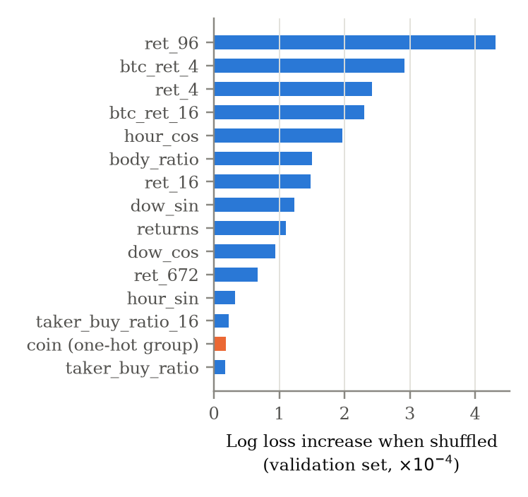
Figure 4: Permutation importance of the 15 most important inputs of the random forest on the validation set (the coin indicators are shuffled as one group).
Fit to the Problem The planned application in Phase IV must predict for any pair in real time. The random forest trains in 19.3 s on all 1.1 million rows and predicts the whole validation set in 0.2 s, while k-nearest neighbors and the kernel SVM take around 55.8 s and 104.5 s and AdaBoost about an hour to retrain. The model takes the pair as a one-hot input, so a single trained model serves every pair. Logistic regression remains a simpler alternative with almost the same performance, which we keep as a fallback.
Test Evaluations We report the order of events openly, because the test set was used more than once. We first selected the random forest and evaluated it on the test set. The second round of neural network tuning then beat it on validation by more than the bootstrap uncertainty, a rule we had fixed before that round, so we switched and evaluated the neural network on the test set. Only afterwards did the seed analysis show that the bootstrap rule had ignored the randomness of training, so we returned to the random forest. This decision is based on the validation results over several seeds, not on the test results, although the test results agree with it (Table 18). The random forest is deterministic for a fixed seed, so its test result is the same in both evaluations.
Table 18: Test results (July 2025 – August 2026).
Model | Accuracy | AUC | Log loss
Majority baseline | 49.9% (down: 50.1%) | 0.500 | 0.6933
Neural network | 52.1% | 0.529 | 0.6928
Random forest (final) | 52.4% | 0.532 | 0.6920
Test Result On the test period the random forest reaches an accuracy of 52.4% and an AUC of 0.532, with a log loss of 0.6920 against 0.6933 for the baseline. The results are slightly lower than on the validation set (52.8%, AUC 0.539), which is consistent with the month-to-month variability of Section 4: the test period is a different market regime, in which downward moves are slightly more common than upward ones, so always predicting an upward move would be right only 49.9% of the time.
Table 19 shows the confusion matrix of the random forest on the test period. It predicts an upward move for 52.8% of the instances while only 49.9% are upward, so it leans slightly toward upward moves, a bias inherited from the training period, in which 50.7% of the moves were upward. It identifies 55.3% of the upward moves and 49.6% of the downward moves.
Table 19: Confusion matrix of the random forest on the test period.
 | Predicted down | Predicted up
Actual down | 74,160 | 75,493
Actual up | 66,812 | 82,494
6. Limitations
Some models were trained on samples of the training set (k-nearest neighbors, the kernel SVM and the first rounds of the Bayesian network and the neural network), so they may be disadvantaged compared with the models trained on the full data; for the neural network and the Bayesian network, moving from the sample to the full data improved the results. The best AdaBoost setting is at the edge of its grid, but extending it would take several more hours for an expected gain smaller than the bootstrap uncertainty. The validation set is used both to tune the hyperparameters and to compare the models, so the validation results are slightly optimistic; the test result is the unbiased estimate. Finally, the early stopping of the neural network holds out a random 10% of the training rows rather than the most recent ones; Section 4 shows that this made its result depend on chance. For Phase IV, early stopping on the most recent part of the training period, or averaging several seeds, would make the neural network a fairer candidate.
7. Source Code
All experiments are in src/train.ipynb. Each model has a search cell, which runs its grid and saves the results to out/results, followed by a cell that retrains the best setting and evaluates it in full. Setting SEARCH = True at the top of the notebook reruns every search (about 6.5 hours on 14 cores); with SEARCH = False the saved search results are reloaded and only the final models are retrained. The comparison, variability analysis and test evaluation are at the end of the notebook, and this report is generated from the saved results by report/make_phase3.py.
REFERENCES
[1] Binance. 2026. Binance Public Data. Retrieved October 3, 2026 from https://data.binance.vision
[2] Fabian Pedregosa et al. 2011. Scikit-learn: Machine Learning in Python. Journal of Machine Learning Research 12 (2011), 2825-2830.
[3] Gaspard Ducamp, Christophe Gonzales, and Pierre-Henri Wuillemin. 2020. aGrUM/pyAgrum: a toolbox to build models and algorithms for Probabilistic Graphical Models in Python. In Proceedings of the 10th International Conference on Probabilistic Graphical Models (PGM 2020), 609-612.
[4] Bradley Efron and Robert J. Tibshirani. 1993. An Introduction to the Bootstrap. Chapman & Hall, New York.

